

CO 4 ASESSEMENT TOOL 2
CSA0206 SOFTWARE ENGINEERING
NAME: Alima Banu R
REG NO:192471044
Test Case Design Document
Medication Adherence Tracker for Elderly Patients with Caregiver Alerts

Table of Contents
Introduction 3
2. Requirements to be Tested 3
2.1 Functional Requirements 3
2.2 Non-Functional Requirements 4
3. Test Scenarios 4
4. System Flow Diagrams 4
5. Test Design Techniques Applied 6
5.1 Sample Equivalence Partitioning / BVA — Key Fields 6
5.2 Decision Table — Caregiver Escalation Logic 6
6. Test Cases 6
7. Test Coverage Summary 8
8. Conclusion 9

Introduction
- Problem statement: an elderly patient's medication schedule is tracked; the system reminds the patient at dose time, lets them mark a dose Taken / Missed / Snoozed, and automatically alerts a linked caregiver if a dose isn't confirmed in time — escalating to an emergency contact after repeated misses.
- Purpose of this document: identify requirements to be tested, list test scenarios, and present representative test cases (normal, boundary, invalid, exceptional) using recognized test design techniques, with full requirement coverage.
- In scope: registration, medication scheduling, reminders, dose logging, caregiver alerts/escalation, reports, usability for elderly users, security, and performance/reliability.
- Out of scope: hardware-level wearable testing and clinical correctness of prescribed dosages (assumed entered by a physician/caregiver).

2. Requirements to be Tested

2.1 Functional Requirements
- FR1: Register and manage a patient profile (name, age, contact, medical ID).
- FR2: Register and link one or more caregivers to a patient.
- FR3: Add a medication with name, dosage, frequency, time(s), duration.
- FR4: Edit or delete an existing medication schedule.
- FR5: Send an automated reminder at the scheduled dose time.
- FR6: Allow the patient to mark a dose Taken / Missed / Snoozed.
- FR7: Limit the number of snoozes allowed per reminder.
- FR8: Auto-escalate an alert to the caregiver if a dose is unconfirmed beyond a threshold (e.g. 30 min).
- FR9: Deliver caregiver alerts via multiple channels (push, SMS, email).
- FR10: Maintain a timestamped adherence history log.
- FR11: Generate adherence reports with an adherence percentage.
- FR12: Detect duplicate/conflicting medication time entries.
- FR13: Escalate to an emergency contact after repeated consecutive missed doses.
- FR14: Provide caregivers a real-time adherence dashboard.

2.2 Non-Functional Requirements
- Usability: Elderly-friendly UI — large fonts, high contrast, optional voice reminders.
- Reliability: Reminders fire with ≥99.9% accuracy; no missed/duplicate alerts.
- Performance: App loads ≤3 sec; notifications delivered ≤5 sec of scheduled time.
- Security: Data encrypted in transit & at rest; role-based, authenticated access.
- Availability: Alert service available 24x7, ≥99.5% uptime.
- Scalability: Supports multiple caregivers per patient and multiple patients per caregiver.
- Compatibility: Works correctly on Android, iOS, and web.
- Data Recovery: Adherence logs survive crashes/restarts via automatic backup.
- Accessibility: Screen-reader support and large touch targets.

3. Test Scenarios
Scenarios below were derived directly from the requirements and drive the test cases in Section 5.
- Registration & Linking: Register a new patient with valid details. Link / unlink a caregiver to a patient. Reject registration with missing or invalid data.
- Medication Scheduling: Add, edit, and delete a medication schedule. Reject invalid dosage or duplicate time slots.
- Reminders & Dose Logging: Deliver a reminder at the scheduled time. Mark a dose Taken, Missed, or Snoozed. Enforce the maximum snooze limit.
- Caregiver Alerts & Escalation: Escalate an alert once the confirmation window elapses. Deliver alerts via push/SMS/email. Escalate to an emergency contact after repeated misses.
- Reports & Dashboard: View adherence history and generate reports. Reflect real-time status on the caregiver dashboard.
- Usability, Security & Reliability: Verify elderly-friendly UI, login/access control, and behavior under server/notification failure.

4. System Flow Diagrams
The two diagrams below illustrate the core logic the test cases in Section 6 are built around.
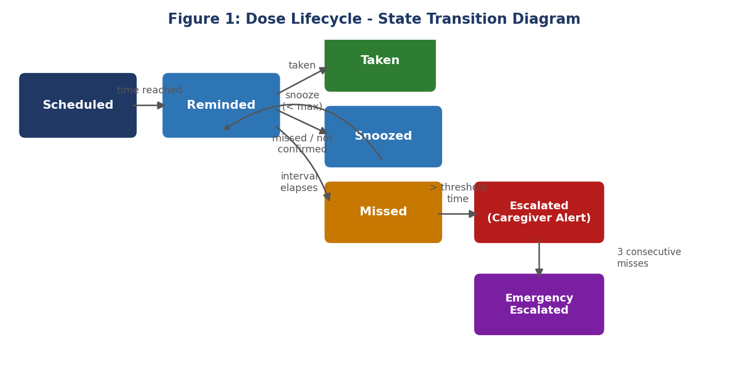
Figure 1: Dose lifecycle — state transitions from Scheduled through to a terminal state.
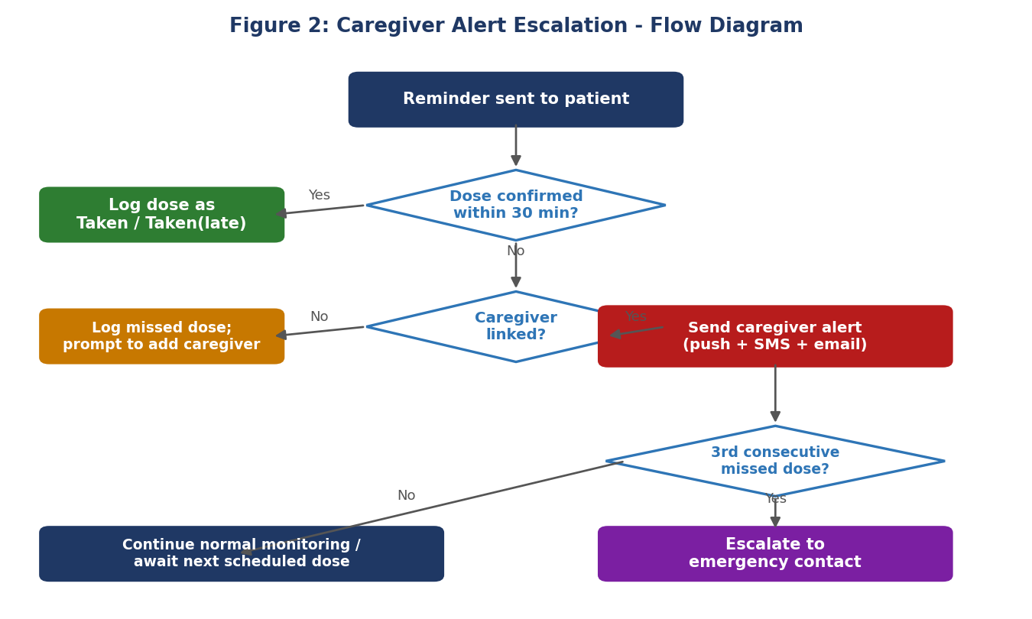
Figure 2: Decision flow for caregiver alerting and emergency escalation.

5. Test Design Techniques Applied
- Equivalence Partitioning & Boundary Value Analysis: applied to numeric inputs — dosage (valid 1-10), age (valid 18-120), snooze count (valid 0-3), and escalation threshold (30 min) — testing boundary values just inside and outside each valid range.
- Decision Table Testing: used for the caregiver-escalation logic in Figure 2, which depends on three independent conditions: dose confirmed, time elapsed vs. threshold, and caregiver linked.
- State Transition Testing: used for the dose lifecycle in Figure 1, covering every valid transition (Scheduled → Reminded → Taken/Snoozed/Missed → Escalated → Emergency Escalated).

5.1 Sample Equivalence Partitioning / BVA — Key Fields
Field | Valid Partition | Invalid Partition | Boundary Values
Dosage (units) | 1 - 10 | ≤0, >10, non-numeric | 0, 1, 10, 11
Patient age (yrs) | 18 - 120 | <18, >120, negative | 17, 18, 120, 121
Snooze count | 0 - 3 | negative, >3 | 0, 3, 4
Escalation threshold (min) | 0-30 no alert, >30 alert | negative | 29, 30, 31

5.2 Decision Table — Caregiver Escalation Logic
Rule | Confirmed? | Elapsed > 30 min? | Caregiver Linked? | Action
R1 | Yes | No | Yes | No alert; logged as Taken.
R2 | No | Yes | Yes | Caregiver alert triggered on all channels.
R3 | No | Yes | No | Missed dose logged; no alert (no caregiver linked).
R4 | No | Yes | Yes (3rd miss) | Caregiver alert + emergency contact escalation.

6. Test Cases
Representative test cases covering normal, boundary, invalid, and exceptional conditions across all modules. 'Actual Result' and 'Status' are left for the tester to complete during execution.
TC ID | Test Scenario | Steps & Test Data | Expected Result | Actual Result | Status
TC_01 | Register patient (Normal) | Enter valid name, age 72, phone, medical ID; submit. | Profile created successfully. | Not Executed | Pending
TC_02 | Register patient (Invalid) | Leave Name blank; submit. | Validation error: 'Name is required'. | Not Executed | Pending
TC_03 | Link caregiver (Normal) | Add caregiver by email; confirm invite. | Caregiver linked and appears in list. | Not Executed | Pending
TC_04 | Link caregiver (Exceptional) | Link the same caregiver a second time. | System blocks duplicate link. | Not Executed | Pending
TC_05 | Add medication (Normal) | Name, dosage=2, frequency, time; save. | Medication saved with correct reminder times. | Not Executed | Pending
TC_06 | Dosage boundary — min (BVA) | Enter dosage = 1 (min valid); save. | Accepted. | Not Executed | Pending
TC_07 | Dosage boundary — max (BVA) | Enter dosage = 10 (max valid); save. | Accepted. | Not Executed | Pending
TC_08 | Dosage invalid — zero (EP) | Enter dosage = 0; save. | Rejected: 'Dosage must be at least 1'. | Not Executed | Pending
TC_09 | Dosage invalid — exceeds limit | Enter dosage = 11; save. | Rejected: 'Dosage exceeds allowed limit'. | Not Executed | Pending
TC_10 | Duplicate time slot (Exceptional) | Add two medications at the same time. | System flags a scheduling conflict. | Not Executed | Pending
TC_11 | Reminder delivery (Normal) | Reach scheduled dose time. | Reminder delivered within 5 sec (NFR). | Not Executed | Pending
TC_12 | Mark dose Taken (Normal) | Receive reminder; tap 'Taken'. | Logged as Taken with timestamp. | Not Executed | Pending
TC_13 | Snooze limit boundary (BVA) | Snooze a 3rd time (max = 3). | 3rd snooze accepted; no further snoozes allowed. | Not Executed | Pending
TC_14 | Snooze exceeds limit (Invalid) | Attempt a 4th snooze. | Blocked; forces Taken/Missed decision. | Not Executed | Pending
TC_15 | Alert boundary — 29 min (BVA) | Confirm dose at 29 min. | No caregiver alert sent. | Not Executed | Pending
TC_16 | Alert boundary — 31 min (BVA) | Leave unconfirmed past 31 min. | Caregiver alert sent. | Not Executed | Pending
TC_17 | Multi-channel alert (Normal) | Trigger escalation with push+SMS+email enabled. | Alert delivered on all 3 channels within 5 sec. | Not Executed | Pending
TC_18 | No caregiver linked (Exceptional) | Miss a dose with no caregiver linked. | Missed dose logged; prompt to add caregiver; no alert sent. | Not Executed | Pending
TC_19 | Emergency escalation (Exceptional) | Miss 3 consecutive scheduled doses. | System escalates to the emergency contact. | Not Executed | Pending
TC_20 | Adherence report (Normal) | Generate a monthly report (54/60 taken). | Report shows 90% adherence, correctly calculated. | Not Executed | Pending
TC_21 | Report boundary (Boundary) | Generate a report for a day with 0 scheduled doses. | Shows 'No data' rather than a divide-by-zero error. | Not Executed | Pending
TC_22 | Caregiver dashboard (Normal) | Patient confirms a dose; caregiver opens dashboard. | Status updates in real time, no manual refresh needed. | Not Executed | Pending
TC_23 | Login security (Invalid) | Enter the wrong password 3 times. | Account temporarily locked after 3 attempts. | Not Executed | Pending
TC_24 | Unauthorized access (Exceptional) | Unlinked caregiver tries to view a patient's data. | Access denied; no data exposed. | Not Executed | Pending
TC_25 | Server outage recovery (Exceptional) | Simulate a 10-min notification outage, then restore. | Queued reminders/alerts are retried and delivered; none dropped. | Not Executed | Pending

7. Test Coverage Summary
Every functional and non-functional requirement maps to at least one test case above:
- Registration & linking (FR1, FR2): TC_01-TC_04
- Medication setup (FR3, FR4, FR12): TC_05-TC_10
- Reminders & dose logging (FR5-FR7): TC_11-TC_14
- Caregiver alerts & escalation (FR8, FR9, FR13): TC_15-TC_19
- Reports & dashboard (FR10, FR11, FR14): TC_20-TC_22
- Security (NFR - Security): TC_23, TC_24
- Reliability & performance (NFR - Reliability, Performance, Availability): TC_11, TC_25
- Usability & accessibility (NFR - Usability, Accessibility, Compatibility): verified via UI walkthroughs alongside TC_12, TC_22 on each target platform

8. Conclusion
This document identifies 14 functional and 9 non-functional requirements, 6 scenario groups, and 25 representative test cases spanning normal, boundary, invalid, and exceptional conditions for the Medication Adherence Tracker. Equivalence Partitioning and Boundary Value Analysis validate input fields; the Decision Table and the two flow diagrams validate the caregiver-escalation logic; and the dose-lifecycle diagram anchors state transition coverage. Together these give adequate functional, reliability, and usability coverage of the system.

